CARTOGRAPHIE DES ULIS école

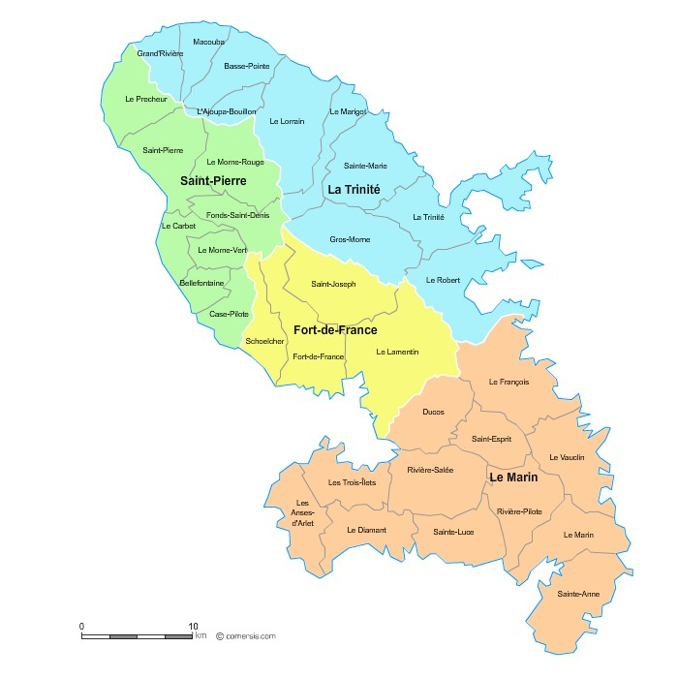

2

2

8

2

44
2

2

ULIS TFC ULIS TFM ULIS TSA ULIS TSLA
32
1
5
0

 | PIAL | NOM DE L'ETABLISSEMENT | VILLES | STRUCTURES
1 | 12 | Ecole Léon LIN (Ducos) | DUCOS | ULIS TFC
2 | 6 | Ecole Carrière (ex Dizac) | DIAMANT | ULIS TFC
3 | 1 | Ecole Baie des Tourelles A | FDF | ULIS TFC
4 | 1 | Ecole Chateauboeuf A - Théodore BURNET | FDF | ULIS TFM
5 | 1 | Ecole Sandrine ANDRIVON MILTON | FDF | ULIS TFC
6 | 11 | Ecole Aristide Maugée | FDF | ULIS TFC
7 | 1 | Ecole Dillon A-Constant Eudaric | FDF | ULIS TFC
8 | 9 | Ecole Eugène Revert | FDF | ULIS TFC
9 | 11 | Ecole Jean-Baptiste Rouam Sim | FDF | ULIS TFC
10 |  | Ecole Marie-Thérèse Gertrude | FDF | ULIS TFC
11 | 9 | Ecole Yves Goussard | FDF | ULIS TFC
12 | 8 | Ecole Gros-Morne A | GROS MORNE | ULIS TSA
13 | 8 | Ecole Gros-Morne C | GROS MORNE | ULIS TSA
14 | 10 | Ecole Pierre Cirille | TRINITE | ULIS TSA
15 | 5 | Ecole Carbet A -Herman Michel | CARBET | ULIS TFC
16 | 7 | Ecole Emmanuel Bruno C 2 | FRANCOIS | ULIS TFC
17 | 7 | Ecole Emmanuel Bruno C 3 | FRANCOIS | ULIS TFC
18 | 2 | Ecole Gondeau Palmiste B | LAMENTIN | ULIS TFC
19 | 2 | Ecole Long Pré | LAMENTIN | ULIS TFC
20 | 2 | Ecole Pierre Zobda Quitman C2 | LAMENTIN | ULIS TFC
21 | 2 | Ecole Pierre Zobda Quitman- C3 | LAMENTIN | ULIS TFC
22 | 3 | Ecole Isidore Pierre-Louis | LORRAIN | ULIS TFC
23 | 4 | Ecole Marin A et B | MARIN | ULIS TFC
24 | 5 | Ecole Marie Labarde | MORNE-ROUGE | ULIS TFC
25 | 10 | Ecole Edouard Delépine | ROBERT | ULIS TFC
26 | 10 | Ecole Occuline Amazan | ROBERT | ULIS TFC
27 | 7 | Ecole Vauclin Mixte A | VAUCLIN | ULIS TFC
28 | 4 | Ecole En Camée | RIVIERE PILOTE | ULIS TFC
29 | 6 | Ecole Rivière-Salée A | RIVIERE SALEE | ULIS TFC
30 | 6 | Ecole Rivière -Salée B | RIVIERE SALEE | ULIS TFC
31 | 9 | Ecole Anse-Madame B | SCHOELCHER | ULIS TFC
32 | 4 | Ecole Belfond | SAINTE ANNE | ULIS TFC
33 | 4 | Ecole Les Sucriers et Cabrisseau | SAINTE LUCE | ULIS TFC
34 | 3 | Ecole Henri Guédon | SAINTE MARIE | ULIS TFC
35 | 3 | Ecole Rodolphe Richer | SAINTE MARIE | ULIS TFC
36 | 7 | Ecole Les Oiseaux du Paradis | SAINT ESPRIT | ULIS TSA
37 | 8 | Ecole Edouard Marceau | SAINT JOSEPH | ULIS TFC
38 | 5 | Ecole Philémond Montout B | SAINT PIERRE | ULIS TSA

