L.P POINTE DES NEGRES - 9720005Y

L.P POINTE DES NEGRES - 9720005Y

F M

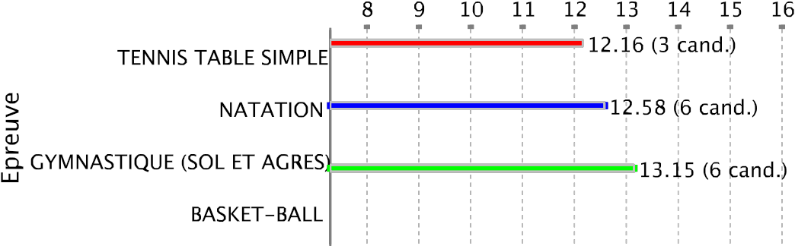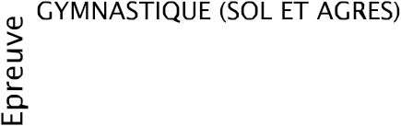

LP PATRONAGE SAINT LOUIS- 9720073X

F M

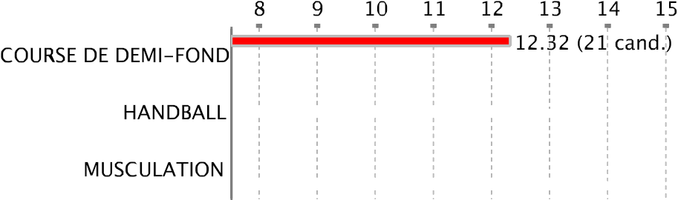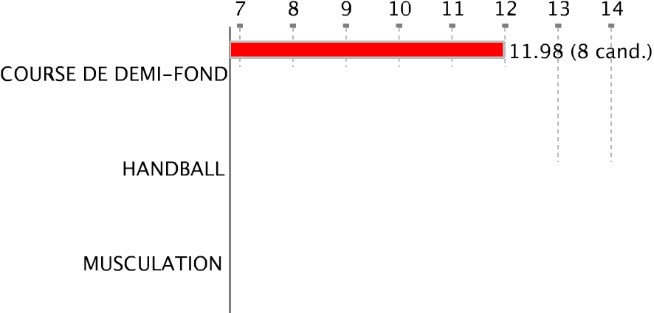

L.P ST JOSEPH CLUNY - 9720074Y

F M

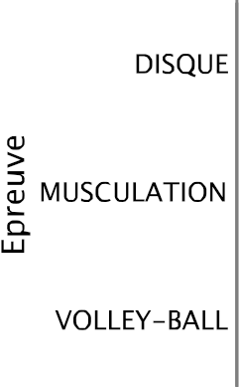

SEP LPO AMEP RAYNAL - 9720082G

F M

L.P PETIT-MANOIR - 9720091S

L.P PETIT-MANOIR - 9720091S

F M

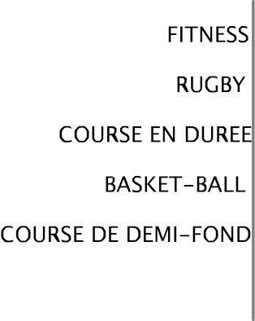

L.P BATELIERE Lumina Sophie- 9720424D

L.P BATELIERE Lumina Sophie - 9720424D

F M

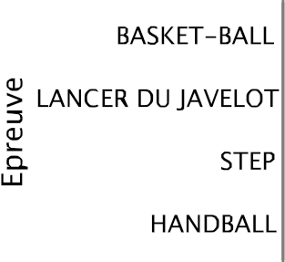

L.P DILLON - 9720429J

F M

L.P FRANTZ FANON - 9720430K

L.P FRANTZ FANON - 9720430K

F M

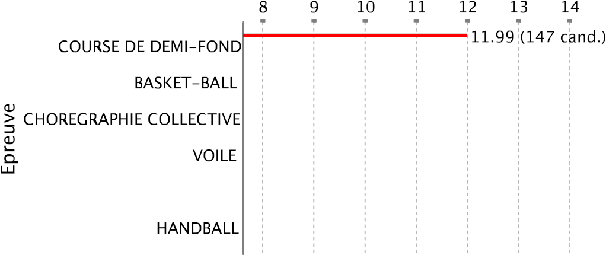

L.P RAYMOND NERIS MARIN- 9720468B

L.P RAYMOND NERIS MARIN- 9720468B

F M

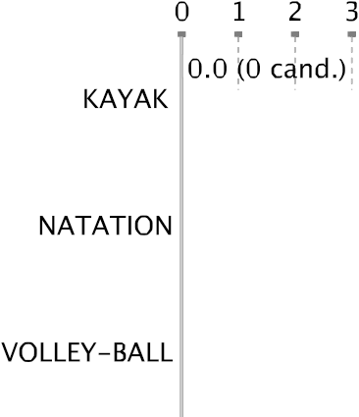

LYC ADVENTISTE RAMA - 9720479N

F M

L.P CHATEAUBOEUF - 9720501M

age 17

L.P CHATEAUBOEUF - 9720501M

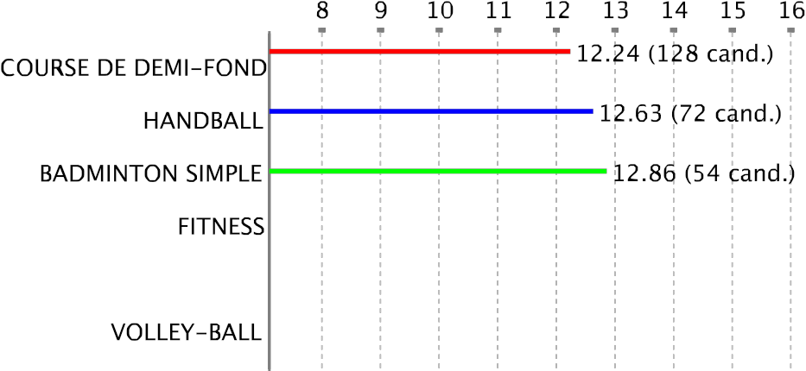

L.P ANDRE ALIKER - 9720515C

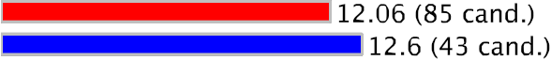L.P ANDRE ALIKER - 9720515C

F M

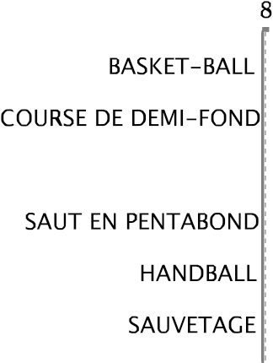

LP SAINT JAMES ST PIERRE- 9720516D

LP SAINT JAMES ST PIERRE- 9720516D

F M

GRET LPO ACAJOU2 - 9720570M

GRET CLG JACQUES ROUMAIN - 9720572P

LYC AMEP - 9720615L

LYC AMEP - 9720615L

F M

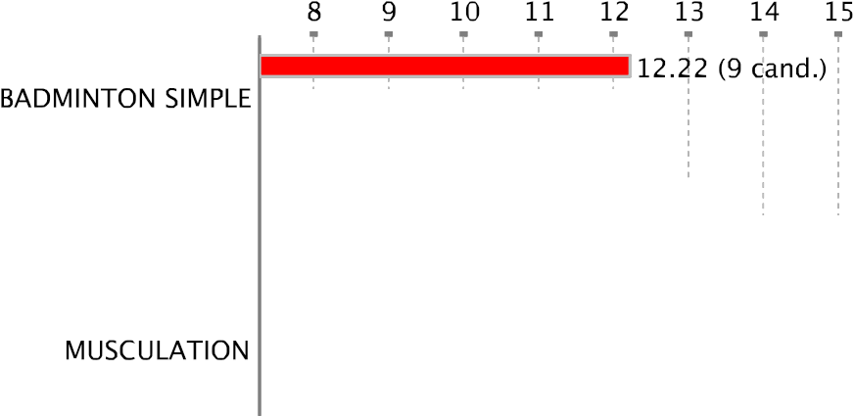

LYC NORD ATLANTIQUE - 9720692V

F M

L.P.O ACAJOU 2 - 9720695Y

L.P.O ACAJOU 2 - 9720695Y

F M

L.P.O JOSEPH ZOBEL - 9720725F

L.P.O JOSEPH ZOBEL - 9720725F

F M

L.P.O J. PERNOCK LORRAIN- 9720726G

age 32

L.P.O J. PERNOCK LORRAIN- 9720726G

GRETA DU BTP - 9720768C

L.P.O LA JETEE FRANCOIS- 9720771F

L.P.O LA JETEE FRANCOIS- 9720771F

F M

GRET CLG LAGROSILLIERE - 9720778N

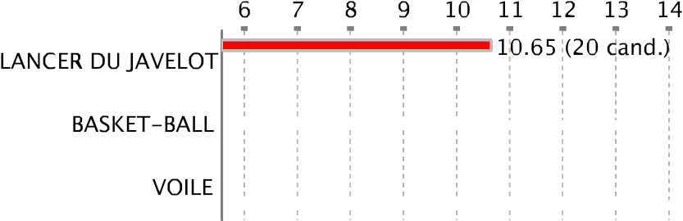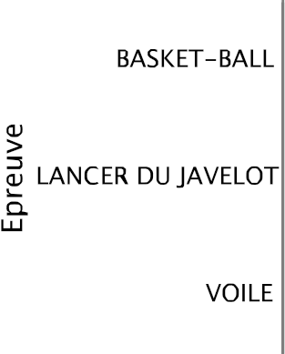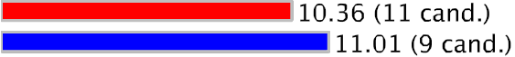

LP FOUR A CHAUX ROBERT- 9720779P

F M

LYC TECHNO-COMPTA FDF- 9720782T

C.N.E.D MARTINIQUE - 9720792D

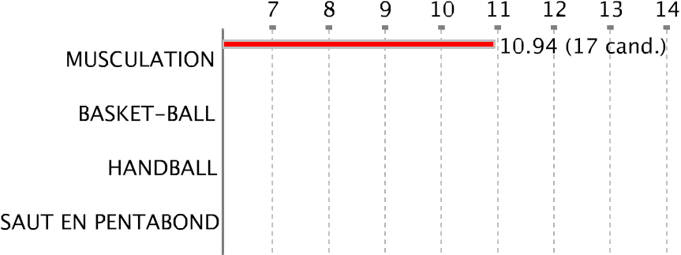

LYC HOTELIER NORD CARAIBES - 9720823M

F M

TSGE EFAC - 9720839E

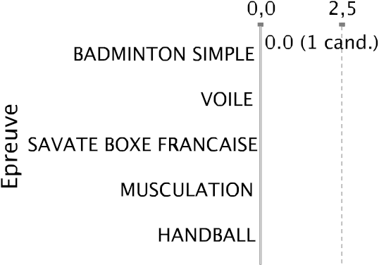

L.P PLACE D'ARMES LAMENTIN- 9720844K

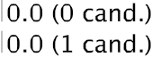L.P PLACE D'ARMES LAMENTIN - 9720844K

F M

