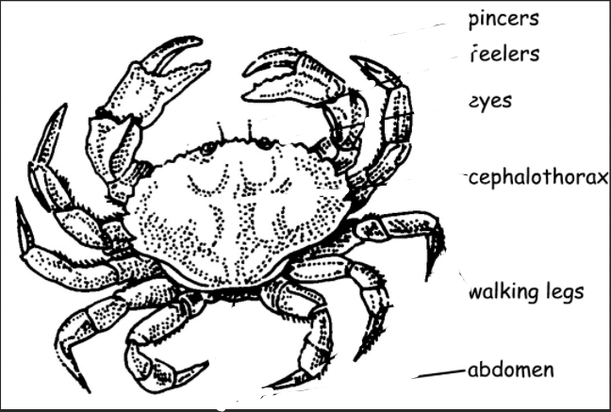

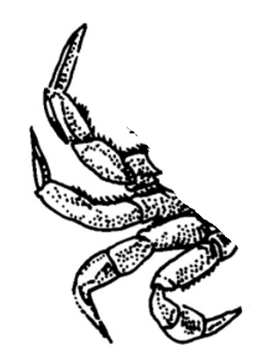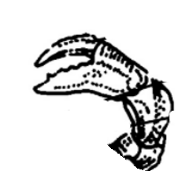

**LEGS**

**EYES**

**& ANTENNAS**

**PINCER**

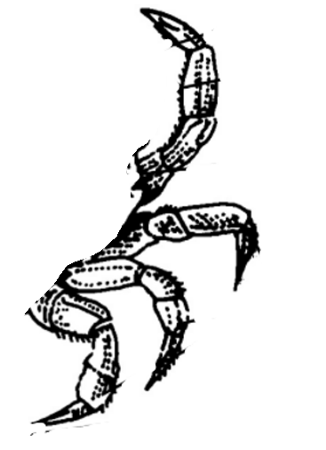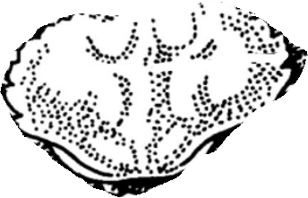

**LEGS**

**CARAPACE**

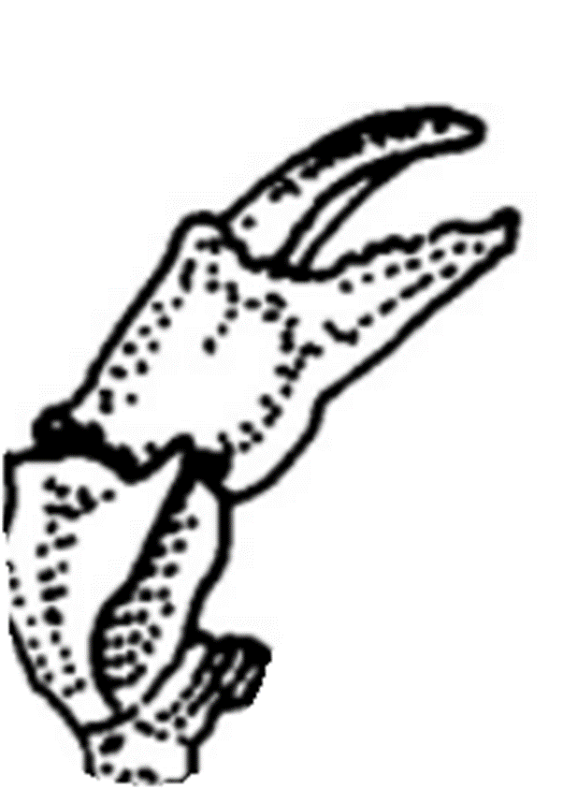

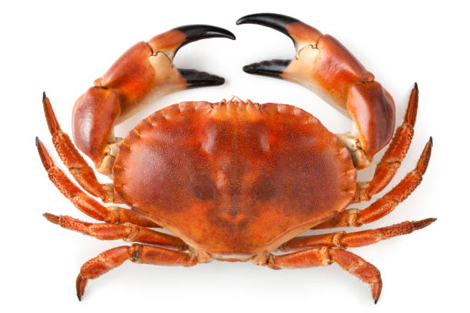

**A CRAB**

**LEGS**

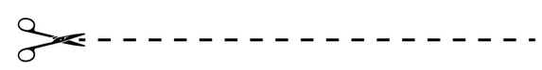

**CARAPACE**

**ANTENNAS**



**A CRAB**

**EYES**



**PINCER**

**GLSE**

**__ __ __ __**



**BCAR**

**__ __ __ __**

**CRPAAAEC**

**__ __ __ __ __ __ __ __**



**YSEE**

**__ __ __ __**

**RPNCEI**

**__ __ __ __ __ __**



**SANNNATE**

**__ __ __ __ __ __ __ __**



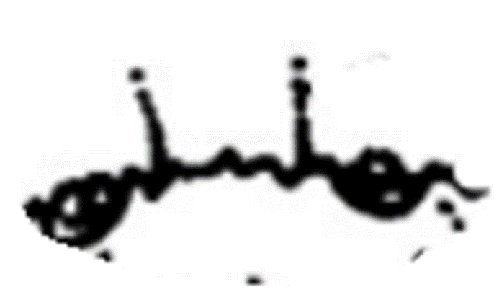

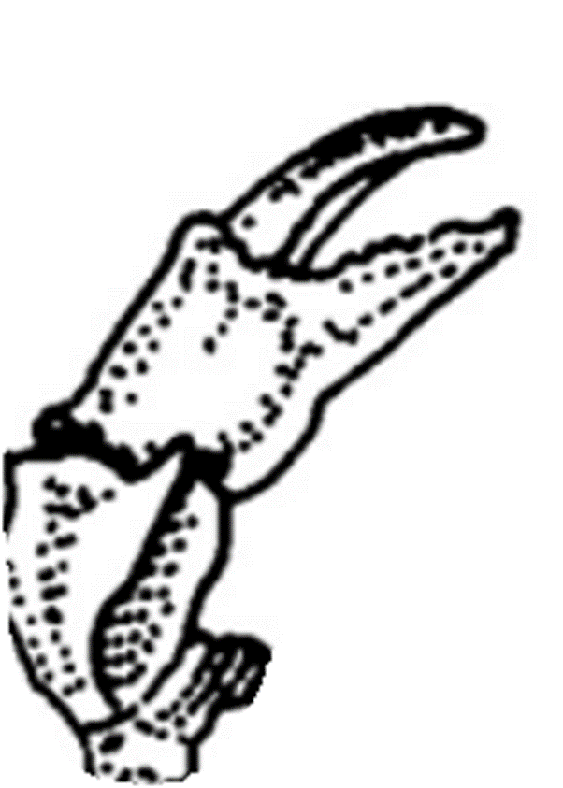

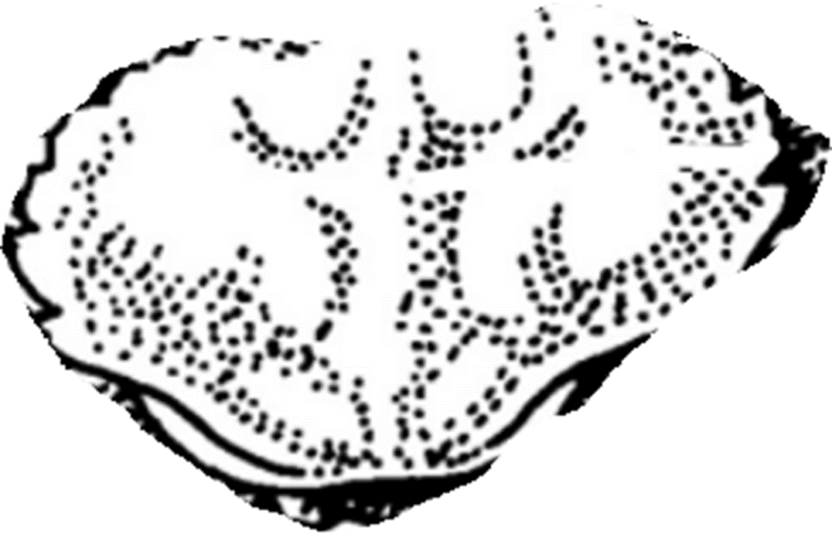

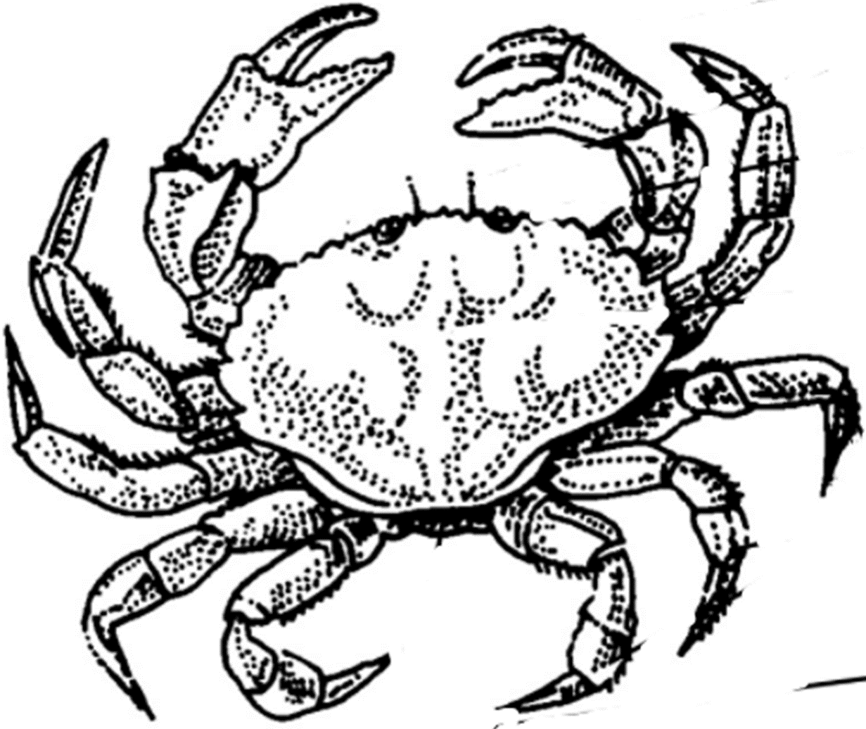

**PINCERS**

**EYE(S)**

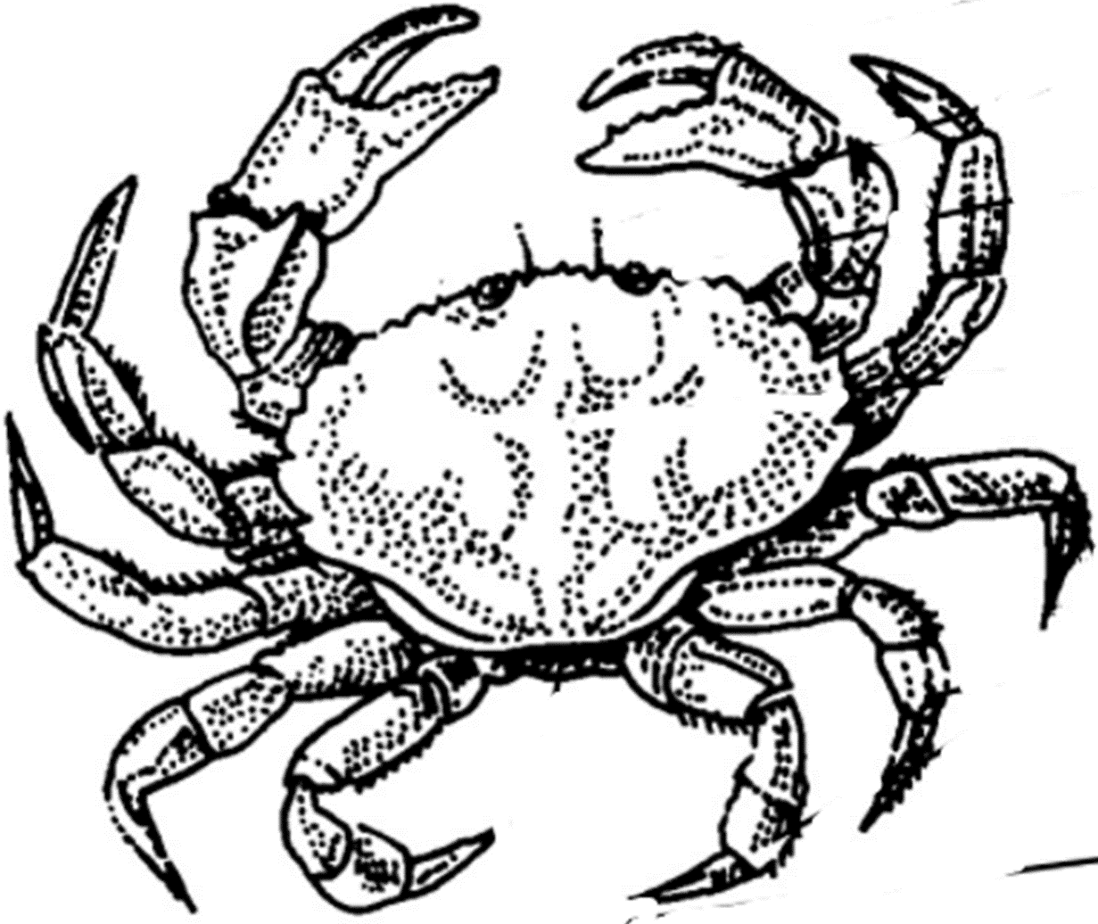

**ANTENNA(S)**

**CARAPACE**

**LEGS**

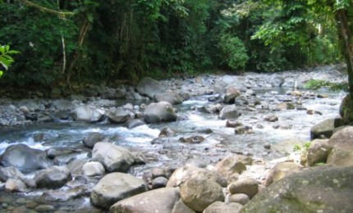

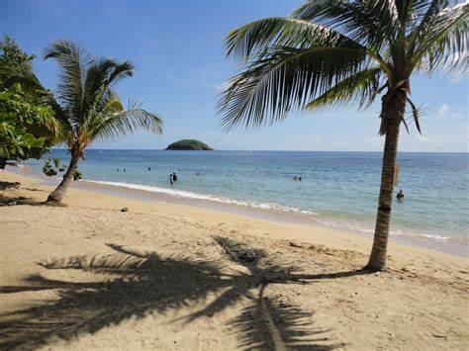

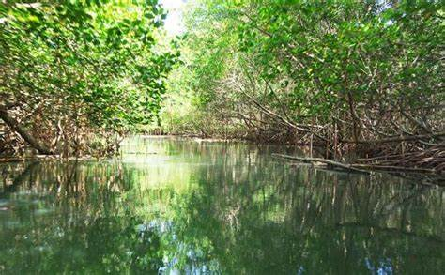

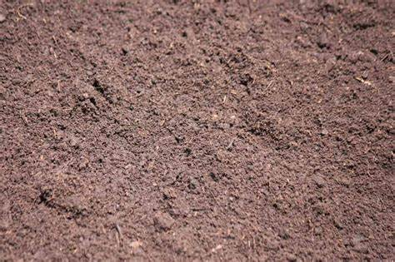

**In the ground**



**In the mangrove**

**On the beach**



**By the river**

**Ground in the**

**_____ _____ _____**



**The on beach**

**_____ _____ _____**

**River by the**

**____ _____ _____**



**The mangrove in**

**_____ ______ _____**