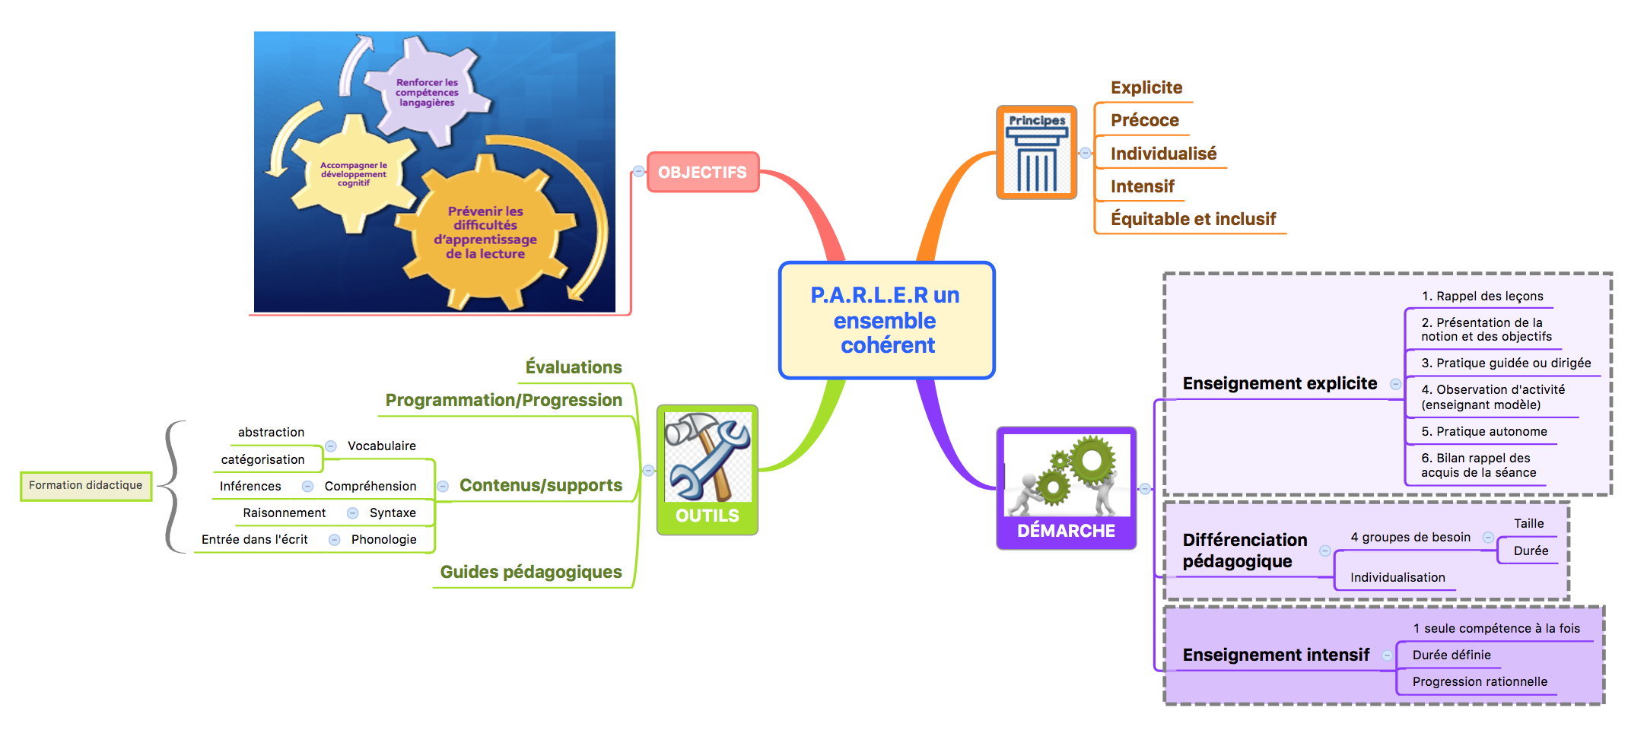
Mission Maternelle
2017 - 2018

