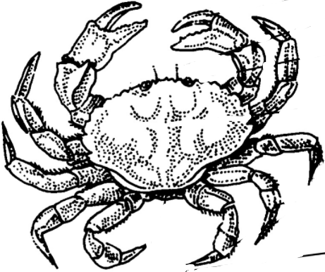
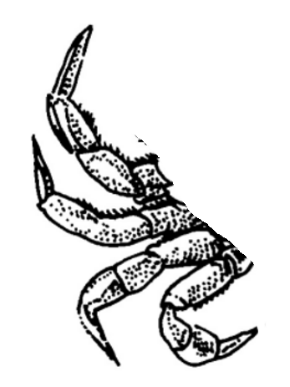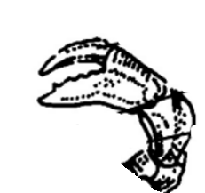
LEGS
EYES
& ANTENNAS
PINCER
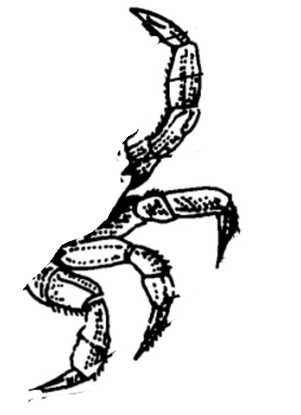
LEGS

CARAPACE

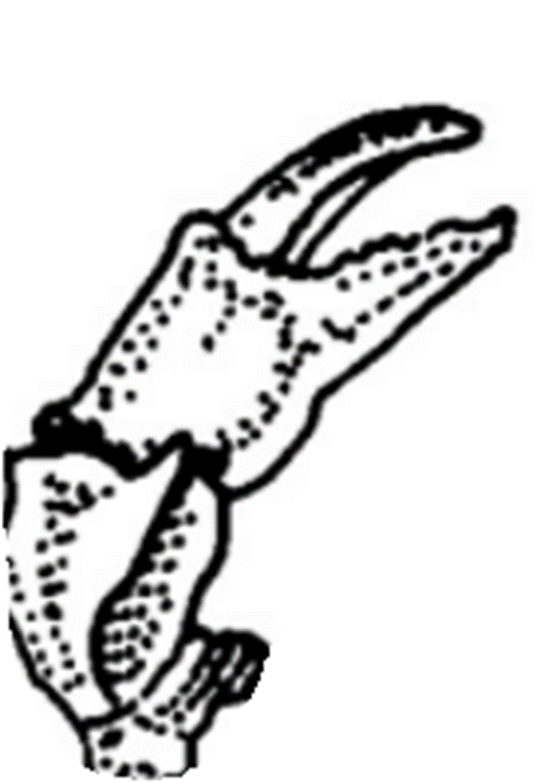

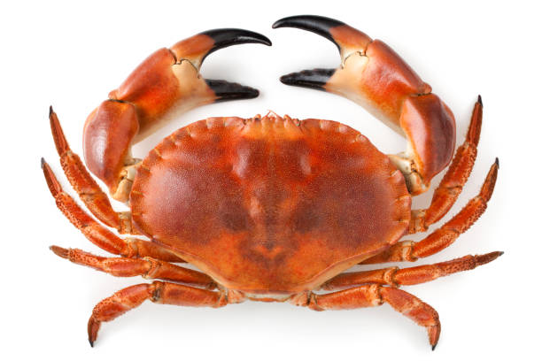
A CRAB

LEGS
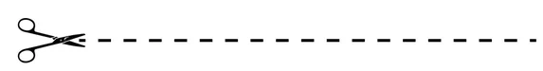
CARAPACE
ANTENNAS
A CRAB
EYES
PINCER
GLSE
__ __ __ __
BCAR
__ __ __ __
CRPAAAEC
__ __ __ __ __ __ __ __
YSEE
__ __ __ __
RPNCEI
__ __ __ __ __ __
SANNNATE
__ __ __ __ __ __ __ __

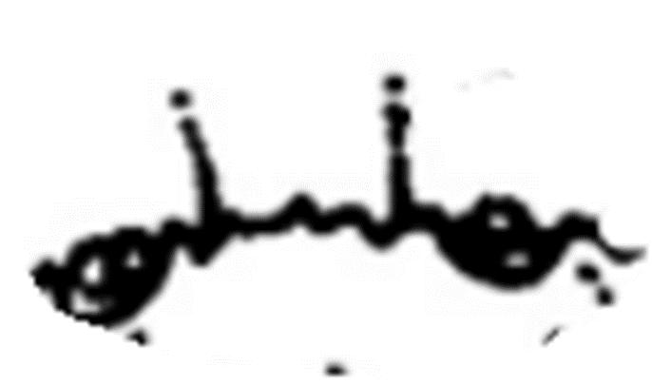

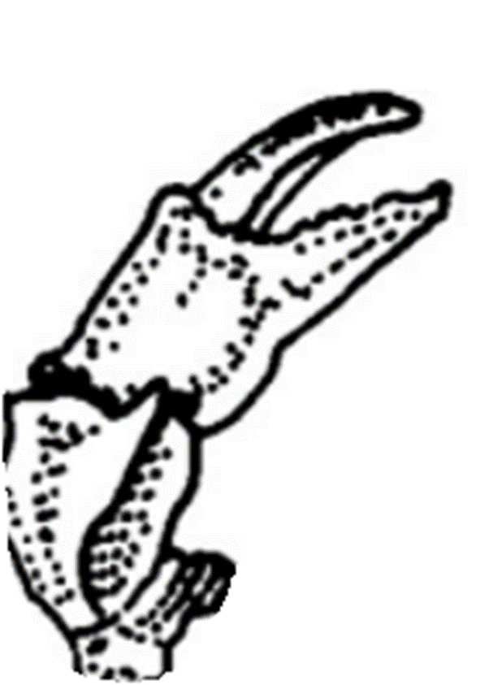

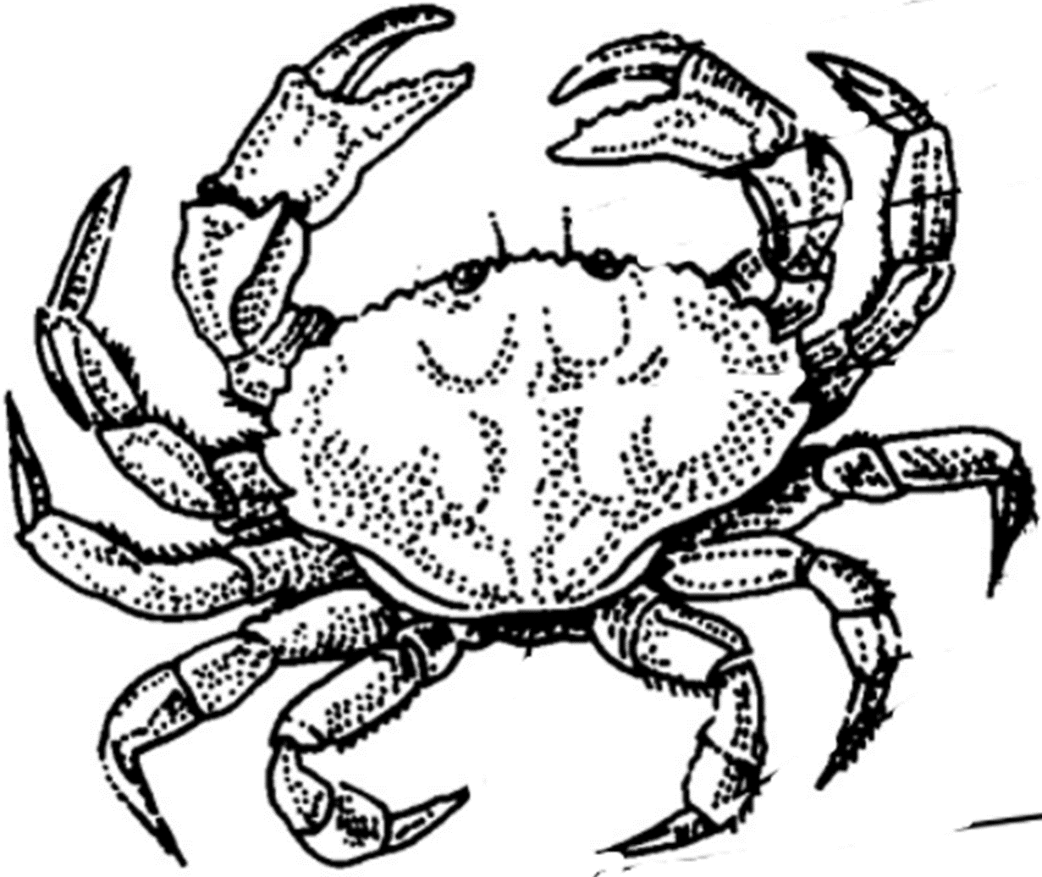

PINCERS
EYE(S)

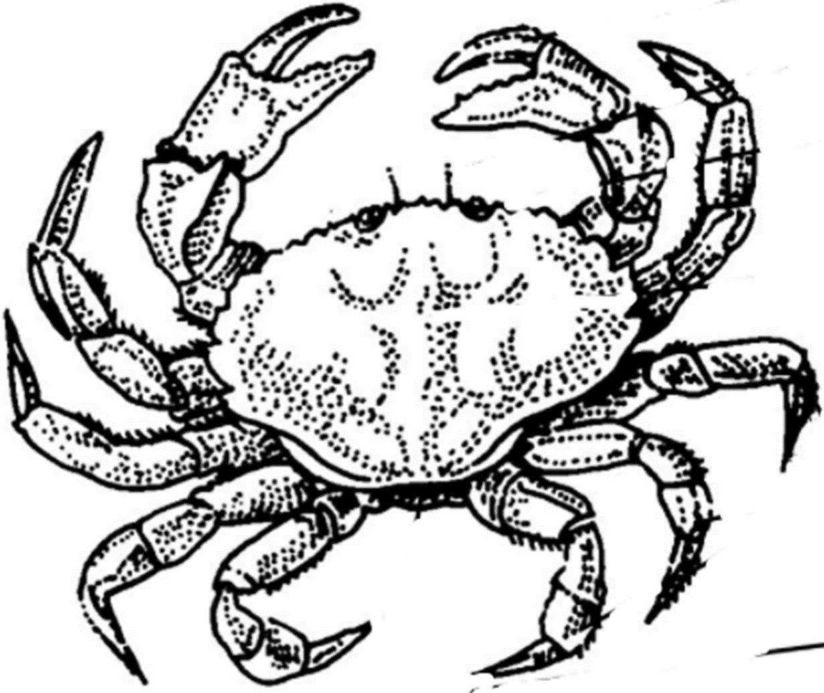
LEGS
CARAPACE
ANTENNA(S)
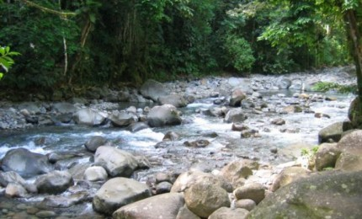
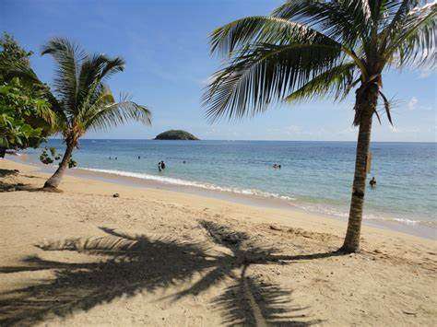
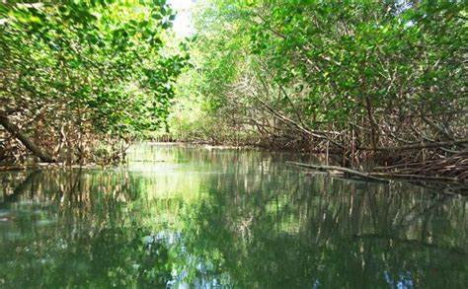

In the ground
In the mangrove
On the beach
By the river
Ground in the
_____ _____ _____
The on beach
_____ _____ _____
River by the
____ _____ _____
The mangrove in
_____ ______ _____

