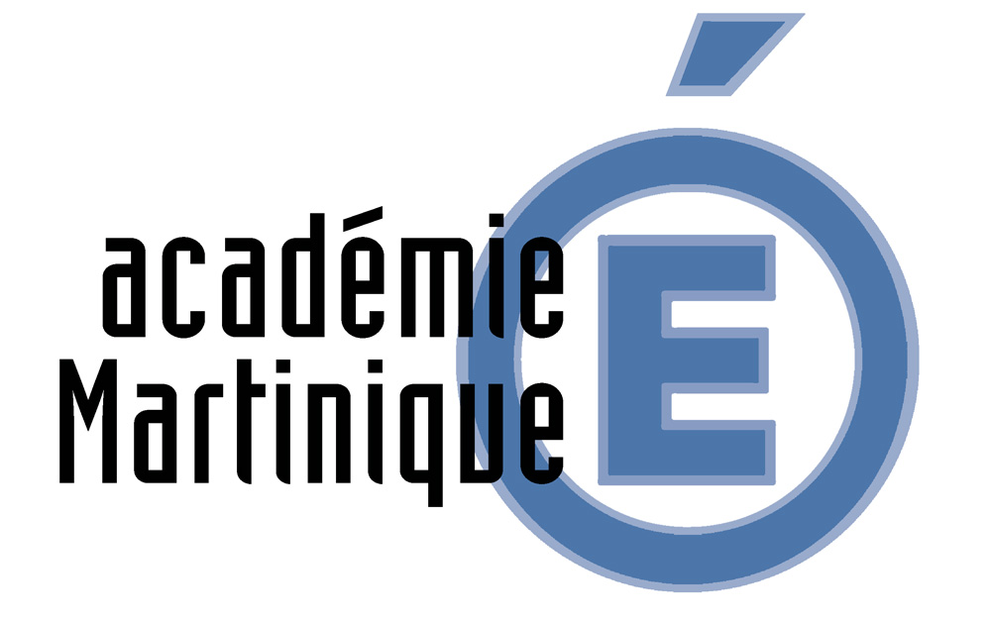
Join the project:
Educating towards
Sustainable Development and Global Solidarity
« Notre monde, my world »

The Dareic in partnership with the Inspectors of the académie de Martinique invites you to join the Project EDD SI (Education au Développement Durable et à la Solidarité Internationale- Sustainable Development and Global Solidarity Education) « Notre monde, my world ».
This project is a wonderful opportunity to gather and motivate educational staff -among whom the teacher in charge of sustainable development- and the pupils around the questions of sustainable development, education of sustainable development and global solidarity. What’s more, it allows teachers from various subjects like history, geography, biology, social studies, social sciences as well as languages to collaborate in teams; this cooperation may help you widen the scope of existing projects in your schools.
Any school can join the project, whether already involved in the domains of sustainable development or wishing to work in such a field.
The project has been set up by a group of six académies and their partners; it has been designed after the principle of The eight Millennium Development Goals (MDGs) voted by the United Nations in 2000, – which range from halving extreme poverty rates to halting the spread of HIV/AIDS and providing universal primary education, all by the target date of 2015 – form a blueprint agreed to by all the world’s countries and all the world’s leading development institutions. They have galvanized unprecedented efforts to meet the needs of the world’s poorest.
These goals will be redefined after 2015. A process of inclusive post-2015 development agenda is already in work. The schools participating in the project will take part in this process.
To join the project, you may work with a group of pupils, a class, or a complete school; your topic will be in connection with 3 questions that will have been chosen democratically by the pupils of all the schools participating. Your team will then present the question at the « conference académique »held in the académie of your partner. In this perspective, you will benefit from the back-up of your Dareic as well as trainers in the field of sustainable development. The languages used are either French or/and English. Following the conference académique, each académie and its partners will send a delegation of 16 pupils elected by their peers, to a mock United Nations assembly in Bonn (Germany). These delegates will commit themselves to a diplomatic negotiation in French or in English, aimed at setting up the various propositions chosen and prioritised. The propositions will be forwarded to the Leadership Council of Sustainable Development Solutions Network, created by UN Secretary-general, Mr. Ban Ki-Moon.
You will find more information in the various annexes, as well as the necessary elements enabling you to enlist your school in the project.
ANNEXES

Description, objectives, perspectives, agenda of the projet

Schools concerned:
All schools dealing with secondary education.
The project aims at developing the key competences of the pupils, according to the common frame Common European Framework for Europe Competence, based on knowledge, skills, competences and culture; it mobilises skills in the domains of initiative, autonomy, citizenship, interaction and communication, as well as it provides pupils with scientific or cultural knowledge which they can then apply in complex situations.
This cooperation will enable teachers to exchange their experiences, to enrich their pedagogical approaches, and set up an international network. The pupils involved will also be enhanced as they will contribute to an original project within the frame of the school project.
Educational and pedagogical objectives :
* Contributing to developing cultural and social interaction among the youth which will be experienced throughout the project.
* Helping pupils become aware of the questions of Sustainable Development and Global Solidarity on several levels (national, European, global).
* Triggering off further international dynamics via the practice of languages.
* Developing social and civic skills by helping pupils do research, negotiate, debate and take decision democratically.
* Staging, widening and improving the fundamental skills of communication and interaction, in French or in English, as well as improving the knowledge in sciences or technology….
* Combining the knowledge on sustainable development (biodiversity, globalization) to nurture an innovative cross-cultural project.
* Developing and mobilizing digital skills to improve access to data online, analyze and use the available tools.
* Stirring up and developing initiatives and entrepreneurship, as well as a sense of responsibility and judgment.
* Teaching the pupils how to learn, by involving them actively in the international survey proposed by the United Nations, in the frame of the MDGs, developing teamwork and training for the simulating of a multilingual and global debate.

TIMETABLE:

1st step: September 2013: schools enlist by mailing the registration coupon to the Directrice de l’Alliance Française Carole Bogdanovscky : carole.bog@gmail.com
.Deadline is October 18th.

2nd step: November 8th 2013: registered schools complete the survey available on the site of the UN « My World » (school level, class level, or group level). See annex n°1. Annex n°2 will help collect the various votes for each group.
The schools then report the global results on the document (see annex n°3) and mail them to the Directrice de l’Alliance Française Carole Bogdanovscky : carole.bog@gmail.com

3rd step: November 2013: the 3 main questions elected by all schools will be announced. Each académie will then represent a group of countries members of the UN. Each school will base its work on one specific country, it will have to understand and defend its views and claims according to the 3 main questions elected.

4th step: November 2013- January 2014: the schools work on and develop their project. The pupils submit it to their schoolboard for approval.

5th step: February 2014: conférences académiques will gather all schools registered, including the partners abroad. 16 delegates will be designed. They will represent their académie at the conference of the UN in Bonn, Germany.

6th step: May 2014: conference of the United Nations in Bonn, Germany.
All delegates from the 6 academies will simulate a diplomatic negotiation, in accordance with the model of the United Nations. These negotiations will aim at setting up the selected and prioritized amendments. The amendments will be forwarded to the Leadership Council of Sustainable Development Solutions Network, created by UN Secretary-general, Mr Ban Ki-Moon.

Académies of Nancy-Metz, Grenoble, Dijon, La Martinique, Lille and Strasbourg

