CARNIVAL IN MARTINIQUE
The Antilles’ Carnival follows the universal carnival tradition but has a distinctly European and African flavor. In Martinique carnival festivities start on the first Sunday after the Epiphany and reach their climax on Ash Wednesday.
In 2016 these 5 days of celebration are from Saturday 6 to Wednesday 10 February.

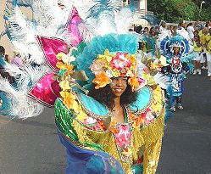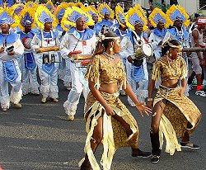

The festivities start straight after the Epiphany, that is to say even up to 2 months before Ash Wednesday. The weekends host street parades, themed events and private celebrations that grow in intensity as the season progresses.
The local government and community representatives meet to organize the festivities; every Sunday sees processions throughout the island.
Every village elects a Queen and Junior Queen to be carried in triumph at the grand parade, in Fort-de-France, on Fat Sunday. Even the grandmothers compete for the honor, dressing in their finest traditional costumes.
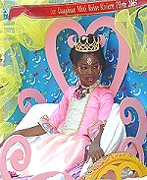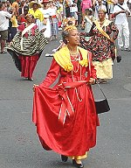

Hidden from prying eyes each village has prepared new costumes and props which are unveiled only for the “vidé” or Carnival Parade which occupies the streets of Fort de France for the 5 days....

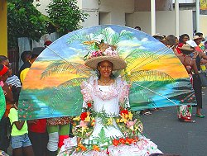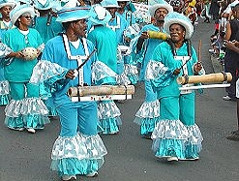
During the carnival the daily life of Martinique comes to a standstill and the island comes alive with “Carnival Fever”. Preparations start months in advance.
During the five days of official celebration many of the younger generations don’t sleep, parading by day and partying by night.

The Carnival King, or VAVAL (a satirical mannequin representing a politician, a public figure or an institution), is carried through the streets leading the festival parade. The Carnival Queen, elected from the various villages, is seated beside the Vaval during the parades.

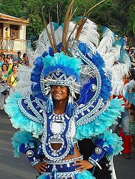

Martinique’s most famous musical groups spread out across the island between the parades ensuring the villages are filled with music 24 hours a day and drawing the crowds along in their wake.

The carnival is also an opportunity to show off the traditional masks of the island:
The red clay men wear masks covered entirely in red clay, the nègs gwo-sirop, men coated from head to toe in sugar syrup and charcoal (are caricatures of the rebel slaves from Africa in contrast to the native Creole islanders); mariann lapofig, dressed entirely in banana leaves; the moko-zombis are dancers on African inspired trampolines; the guiablesses…mingling in glitzy costumes both the beautiful girls of the island as well as the young men cross-dressing in the abandon of the moment.
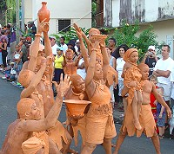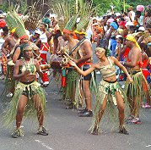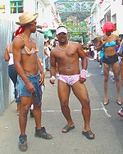
During the Vidè the island throbs with pulsing music, tambourines, trumpets and horns are accompanied by steel drums, bamboo sticks even pots and pans become percussion instruments, the rhythms overlapping from Zouk to Biguine or Dancehall.
There is even a street parade in pyjamas that heads off at 5 am filling the streets of different cities with the shuffling of “slippered” feet.
The pinnacle of the festivities is during the four days leading up to Ash Wednesday.
Every day has its theme, Saturday and Sunday everyone dresses up as they please, Monday is the day of Burlesque Weddings, men dressed as brides parading on foot, float and bwadjak (old cars)....
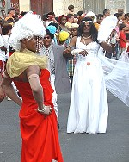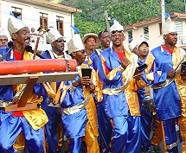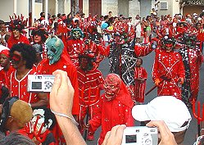

Tuesday is the day of the devil: everyone dressed in red and costumed as the devil. It’s the day when people eat Fat Tuesday fritters (see recipe below). Finally on Ash Wednesday, the day dedicated to the joyeuses pleureuses (devilettes, devils that cry for the death of Vaval), all dressed in black and white of mourning for the death of Vaval, who is symbolically burnt on a bonfire at nightfall.
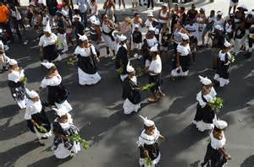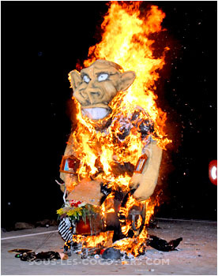

At the end of the celebration the island enters the period of Lent that leads up to Easter.
Lent, the period of fasting and abstinence coincides with the dry season on Martinique. Tradition requires that one does not dance, listen to music and all weddings and other celebrations are postponed until after Lent.
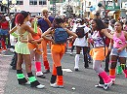
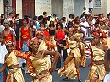
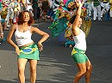
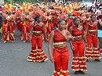
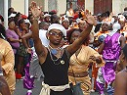

A bit of history…..
The carnival was first celebrated in Martinique at Saint Pierre by the French Catholics in the 18° century. In the 17° and 18° century it was a celebration reserved for the rich colonies, with elegant receptions in costume.
Only after the abolition of Slavery in 1848 the carnival was democratized and adopted its characteristic style, influenced by the former slaves’ adaptation of their own beliefs and traditional instruments: tambourines, cha-cha, ti-bois…
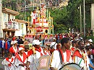

The Carnival of Saint Pierre
From 1848 to 1902 the Carnival of Saint Pierre was particularly renowned in Martinique, despite the fact that the celebrations at the time were overshadowed by the discrimination of the time. In effect, one side of the colony was celebrating with masked balls, private banquettes and luxurious costumes whilst the other side of the island was occupied with celebrations of the vidés nègres. After the catastrophe of Saint Pierre, the carnival festivities were halted for 2 years in Martinique.
It was upon recommencement that the Carnival relocated its hub to Fort de France

Recipe: Fat Tuesday fritters
http://www.macuisinecreole.fr/2012/02/beignets-de-mardi-gras-antillais.html

From http://www.martinicaonline.it/english/carnival_martinique.htm

