CHRISTMAS IN MARTINIQUE
Christmas in Martinique is as much about private homes, public buildings and squares decorated as it is in New-York or Paris and as in many places of the world, children dream of the many presents to come.
Christmas in Martinique tell however of a singular story. The filao trees, our version of the Christmas tree sparkle as glittery as a starry night on top of Mount Pelée, the delicate flower we call Fleuri Noel is only at this time of the year, in full bloom and the typically French crèche is re-created either in miniature or, alive in village squares or churches, with human figures and real animals.
The traditional Christmas diner usually centers around, a smoked caramelized ham marinated in advance for a couple of days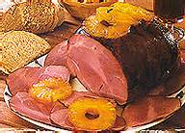,
warm petits pâtés 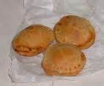,
boudin créole (a zesty West Indian sausage),
yams, and a spicy pork ragout with congo peas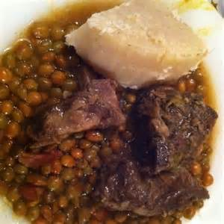,
all topped off with the Bûche de Noël, or Christmas log, for dessert.
Another specialty in Martinique at Christmas, when oranges and tangerines are in great abundance, is shrub, a delicious and very fine liqueur made from the dried peels of the fruit, sugarcane syrup, and white rum. Still other festive drinks include Creole rum punches and spirits flavored with licorice, coconut or hibiscus.
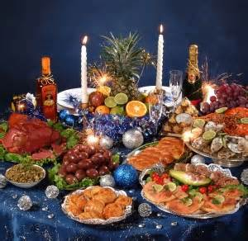

Christmas Carols are the focal point of the holiday season in Martinique. We call it Chanté Noël. 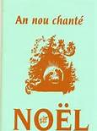
This ancient tradition comes from the middle ages in France where friends and family would gather at each other’s home to celebrate the birth of Christ. In Martinique however, those carols are whole heartedly sung in a distinctively creole way. For the 3 weeks preceding Christmas, people gather at each other’s house, bring food and sing carols all night long. From coast to coast, South to North, from fishermen villages to inland hamlets, the voices of friends, families and neighbors join in Chanté Noël accompanied by the beat of the drums, the pulse of the Ti bwa and sometimes, old fashioned violins and accordions.
Starting from the 1st Sunday of Advent until Christmas Day, these joyful gatherings are one of Martinique’s most treasured traditions and a perfect showcase of the warmth and spirit of the Martinican people.

This year, Christmas holidays are going to start on december18, 2015 and finish on January 4, 2016.

Recipes:
Pork ragout: http://www.tatiemaryse.com/ragout-cochon-antillais/
A very easy one: the pâtés: http://www.tatiemaryse.com/recette-pates-sales-noel/
From http://www.eturbonews.com/41069/christmas-creole-style-martinique

