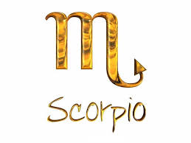
Scorpio : 24th October - 22th November

Weekly horoscope by Mélanie P.

Love: Because of all the events in your life, your love affair is in a bad way. Yet, you are going to make a wonderful encounter. Make no mistake: he or she will be the perfect match.

Work/career: Your efforts will be rewarded: either you’ll get a raise of salary or you'll get well-deserved holidays. But beware of your colleagues.

Health: You should pay attention to your diet as weight gain is stalking you. You also need to exercise.

Luck: This week, neither luck nor love will be waiting for you. However, the presence of your family will be good for you.

