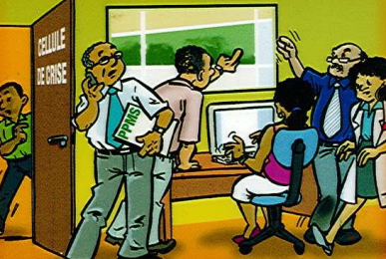
The Safety Plan for the Individual convenes an emergency committee

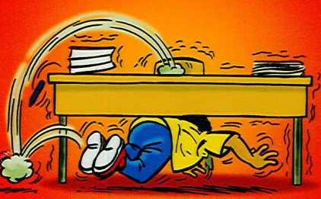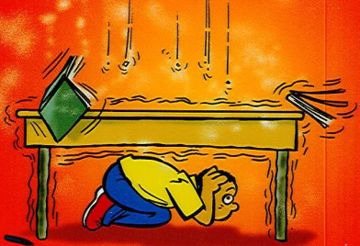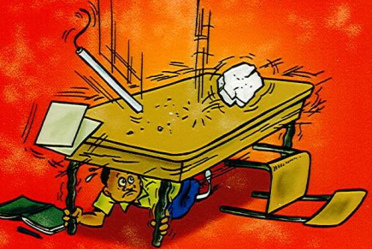
Right from the first tremor, Protect your head Hold the legs of the table, protect yourself under a table if it moves

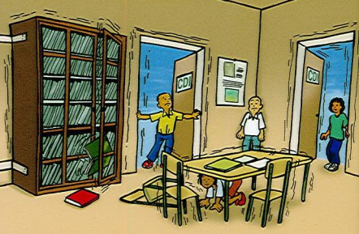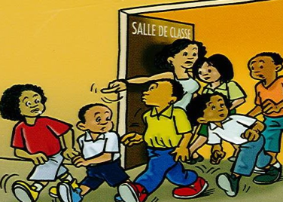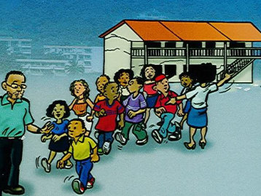
Stay safe in a corner of After the tremor, evacuate Move away from buildings a wall or in a doorway without panicking

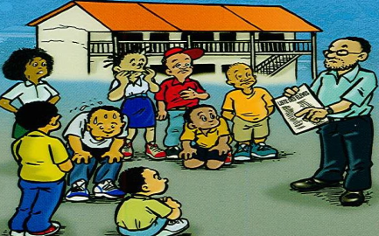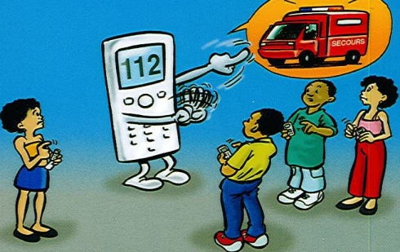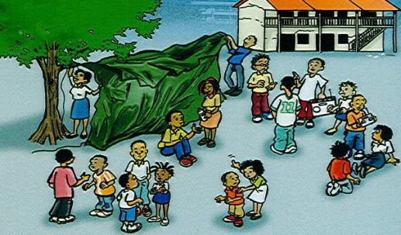
Gather around adults who Do not make phone calls Follow the instructions, are calling the register to let the lines free for listen to the radio and wait
emergency services for emergency services

