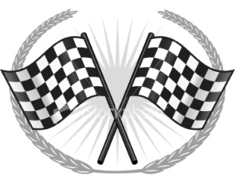

Our Great Pancake Race in FRANCOIS stadium!
Shrove Tuesday is a huge traditional celebration in England. People usually prepare pancakes and have pancake races in the streets. For the occasion, they wear all sorts of funny costumes.
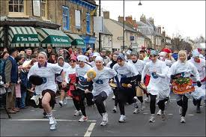

http://traveller-information.blogspot.com/2012/02/pancake-day-shrove-tuesday-funful.html
The pupils from 6e2 organised a pancake race in their town stadium. Two teams competed.
I must win !
(Brice)

It’s tough to toss !
(Yanjie)



Everyone was motivated to win!
Look Axel my pancake is flying! I believe I can fly…
(Ophélie)
Yeah right, flip and fall pancake !
(Axel)

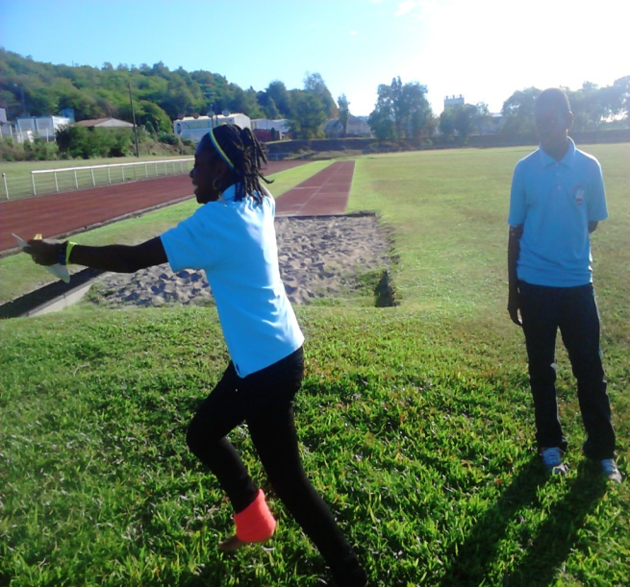

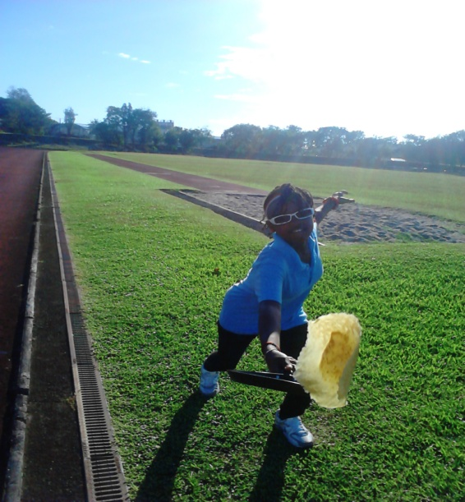
Oh my God! My poor pancake!!!
(Chloé)

Oups, Yanjie’s team lost because he didn’t listen to the teacher’s rules.
I’m so angry !
(Aude)

What have you done, Yanjie?! Listen to the rules!
So funny !
Sorry guys…
‘Yanjie)

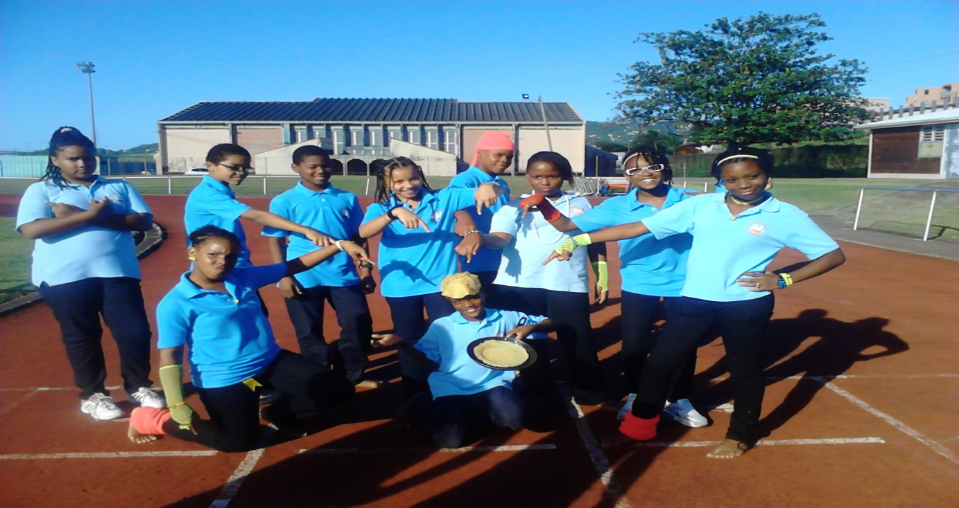

We had tons of fun!

